**Final Project Design: Nuzlocke-Surfer**

Instead of a nuzlocke story where you create your own adventure, I will be creating a website that turns nuzlockes into trivia-styled progression stories. Each nuzlocke that I acquire will be broken up into parts. Each part will have multiple choice questions that will give you points on correct answer. For example, once the user reads and encounters the following plot point

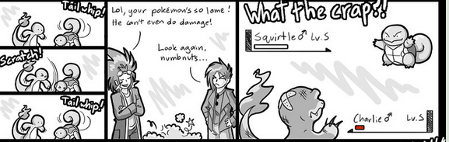

http://yindragon.deviantart.com/art/FireRed-Kick-Mode-Ep-1-4-266817572

They will asked a question. A question for this panel would be: will Charlie survive? The answer that would reward points would be yes. The wrong answer would provide no points. On questions with more answers I’m considering taking away points based on the incorrectness of the answer. I’ll acquire enough content to give users a good selection of fun nuzlockes to read, and some incentive to pay attention to the story as well (but who wouldn’t)

Upon further inspection I realized that the world is lacking a website where nuzlockes can be gathered together for intensive and amazing reading experience. Le done. My website is going to allow creators to have accounts and post their content up for the world to see. I love reading nuzlockes, both veteran creators and non-vets, and think it’d be a great idea for others to be able to come together and do this as well. If people want to play through the game and keep tabs on their stories (for the fanfics out there) I think it’d be great to allow that as well! Because while reading through a comic called “understanding comics” for another class of mine I realized that comic writers take a lot of time and thought and place their works where they are for a reason. Messing with that order may ruin the effect.

Accounts are hard, he says you can probably try faking it but the idea of a hub for Nuzlockes is great

Maybe not account, but like nuzlockes in one place, and if you want to reach the original creators you may.

Sort of like going to wizard101 wiki getting what information you want then going there or just reading what you’d like.